OLIST CUSTOMER
PURCHASE ANALYTICS
Project Report
Customer-level behavioral analytics and repeat-purchase prediction using the Olist Brazilian e-commerce dataset.
Objective: determine whether historical customer purchasing behavior contains useful signal for predicting whether an existing customer will make another delivered purchase during a defined future observation period.

62,145 | 601 | 0.97% | 0.618
Historical customers | Repeat purchasers | Positive-class rate | ROC-AUC

Project repository: https://github.com/ReinSoup/OLIST-Customer-Purchase-Analytics
Related ETL project: https://github.com/ReinSoup/OLIST-Data-Quality-ETL
Scope of submitted implementation
- Data validation and customer identity resolution
- Temporal feature/target separation
- RFM and Average Order Value feature engineering
- Exploratory analysis and class-balance assessment
- Interpretable Logistic Regression baseline
- Imbalance-aware evaluation and threshold analysis

1. Executive Summary
This project extends a previously completed Olist Data Quality & ETL project into a customer analytics and machine learning workflow. The cleaned and validated Olist data is transformed from transactional tables into a customer-level analytical dataset, with historical behavior used as model input and future delivered purchases used as the observed outcome.
The analytical design emphasizes correctness before model complexity. Customer identity is resolved using customer_unique_id, qualifying purchases are restricted to delivered orders, order-item monetary values are aggregated to order level before customer aggregation, and a temporal cutoff separates feature information from the future target.
The final modeling population contains 62,145 customers. Only 601 customers, or approximately 0.97%, made another delivered purchase during the future observation period. This severe class imbalance makes accuracy unsuitable as the primary performance measure.
An interpretable Logistic Regression baseline with StandardScaler and balanced class weights achieved 56.67% recall and 1.36% precision at the default 0.50 threshold, with ROC-AUC of 0.618 and Average Precision of 2.18%. Threshold analysis showed that recall could be increased to 100%, but precision remained close to the underlying positive-class rate.
The result is best interpreted as evidence of some predictive signal, but limited separation from a small initial feature set. The project intentionally stops at this defensible baseline and documents specific next steps rather than overstating model performance.

What the project demonstrates
- Business-question translation into a measurable prediction problem.
- Attention to customer identity and analytical grain.
- Temporal reasoning and prevention of future-information leakage.
- Order-level aggregation before customer-level monetary analysis.
- Feature engineering using interpretable behavioral measures.
- Evaluation designed around a severely imbalanced target.
- Clear documentation of model limitations and future improvements.

2. Business Problem and Project Scope
Core question: Can historical customer purchasing behavior be used to predict whether a customer will make another qualifying purchase during a future observation period?

The project deliberately avoids calling this traditional subscription churn. In a subscription setting, churn is usually tied to a cancellation or lapse event. Olist instead represents marketplace transactions, so the observable event is whether a customer purchases again.
The implemented workflow is intentionally scoped as an MVP. It establishes a complete analytical chain without adding complexity that cannot yet be justified by the data.
Implemented in this report | Not part of the submitted baseline
Cleaned-data loading and validation | K-Means segmentation
Customer identity validation | Random Forest / XGBoost comparison
Delivered-order qualification | SHAP / advanced explainability
Temporal prediction framework | Hyperparameter tuning
RFM + AOV feature engineering | Streamlit / API / MLOps
EDA and class-balance analysis | Large-scale feature expansion
Logistic Regression baseline | Full customer intelligence dashboard
Precision, recall, F1, AP, ROC-AUC | Post-submission propensity expansion
Threshold analysis | Causal or uplift analysis

This distinction is deliberate: the project prioritizes a technically defensible baseline and clear reasoning over a large collection of models.

3. Data Foundation
The project uses the Brazilian E-Commerce Public Dataset by Olist. The current repository does not repeat the full upstream data-quality process; instead, it consumes the cleaned and validated datasets produced by the author's previous Olist Data Quality & ETL project.
Dataset | Rows inspected | Role
customers | 99,441 | Customer identity and location information
orders | 99,441 | Order status and purchase timeline
order_items | 112,650 | Item-level price and freight values used for order value

The source data spans purchase timestamps from 2016-09-04 to 2018-10-17. The model does not use the incomplete October 2018 period as part of the future observation window.
Order-status inspection showed 96,478 delivered orders and 2,963 orders in other states. The project therefore explicitly defines a qualifying purchase as an order with order_status == "delivered".
This definition is applied consistently to both historical feature construction and the future repeat-purchase target.

Relational structure
customers → orders → order_items → products / sellers
The relevant analytical path is customers → orders → order_items. Product and seller relationships remain part of the source data model, but the submitted prediction workflow does not join unnecessary tables merely for additional complexity.

4. Customer Identity and Analytical Grain
Olist contains both customer_id and customer_unique_id. The preparation analysis verified that every customer_id maps to exactly one customer_unique_id, while a customer_unique_id can be associated with multiple customer_id records.
Identity observation | Verified result
Unique customer_id values | 99,441
Unique customer_unique_id values | 96,096
customer_unique_id values linked to multiple customer_id records | 2,997
Analytical customer identifier | customer_unique_id

Using customer_unique_id prevents multiple Olist customer records belonging to the same underlying customer from being treated as separate analytical customers.
Final modeling grain: one row = one customer.

This is a critical modeling decision because the source tables have different grains.

Grain transition
Order Items: 1 row = 1 item within an order
↓
Orders: 1 row = 1 order
↓
Customer: 1 row = 1 customer
The order_items table is at a lower grain than orders. Because one order can contain multiple items, directly joining item rows to customers and then summing monetary values can multiply values incorrectly. The project therefore aggregates item-level price and freight into order-level order_value before calculating customer monetary features.

5. Temporal Framework and Leakage Control
The prediction problem is constructed using a strict historical-to-future framework. Customer features are calculated only from information available by the prediction cutoff. Future behavior is used only to determine the observed target.
Period | Definition | Purpose
Historical feature period | Delivered orders up to 2018-03-31 | Build customer features
Prediction cutoff | 2018-03-31 | Separate past from future
Future observation period | 2018-04-01 to 2018-09-30 | Define repeat purchase

BEFORE CUTOFF
Historical delivered orders
↓
Customer features
↓
MODEL
↓
AFTER CUTOFF
Future delivered orders
↓
Repeat-purchase target
The resulting preparation split contains 64,158 historical delivered orders and 32,156 future delivered orders. There are 62,145 customers with historical qualifying purchases.
The latest historical purchase is 2018-03-30 23:32:46 and the earliest future purchase is 2018-04-01 00:11:32, providing a clean chronological boundary.
The defined future window ends on 2018-09-30, although the latest future purchase actually present in the available data is 2018-08-29 15:00:37. October 2018 is excluded because the source period is incomplete.
Temporal separation is the main leakage-control mechanism: the model never receives future repeat-purchase behavior as an input feature.

6. Feature Engineering
The initial feature set is intentionally small and interpretable. Every feature is derived from historical delivered orders only.
Feature | Definition | Analytical purpose
Recency | Cutoff date − latest historical purchase | How recently the customer purchased
Frequency | Count of unique historical delivered orders | How often the customer purchased
Monetary | Sum of historical order_value | Historical customer spending
Average Order Value | Monetary / Frequency | Typical historical order value

Order value is defined as price + freight_value at the item level and then summed by order_id. Customer monetary value is subsequently calculated from these order-level values.
The final customer-level dataset contains 62,145 rows and no missing values in the four model features.
Frequency is highly concentrated: 60,324 customers have one historical order, 1,680 have two, 114 have three, and the maximum observed frequency is nine. This limited variation is an important contextual limitation when interpreting the model.

Feature distribution and skewness
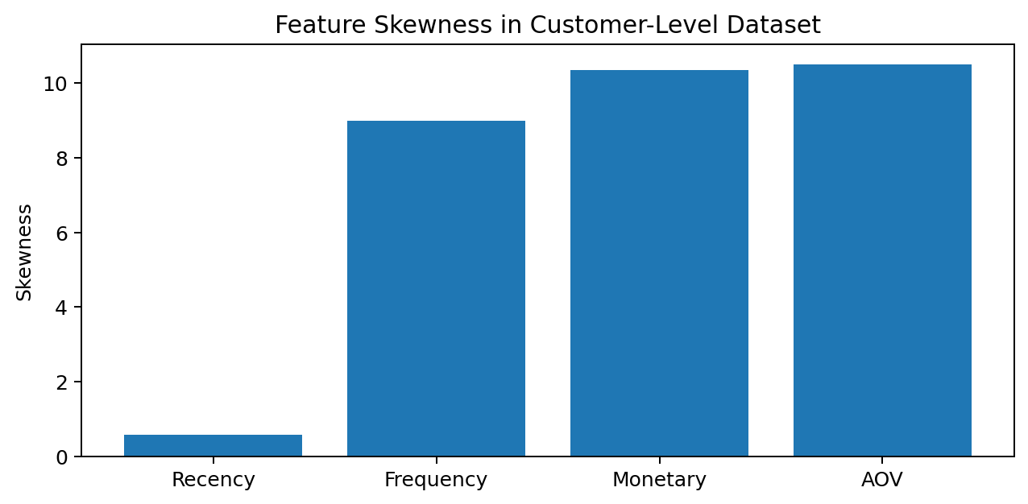
Skewness is especially high for frequency, monetary value, and AOV. This motivated the documented future consideration of transformations such as log scaling, rather than silently adding transformations to the initial baseline.

7. Exploratory Data Analysis
EDA focused on understanding the customer population, feature distributions, class balance, and differences between repeat and non-repeat customers before modeling.
The notebook examined feature distributions, descriptive statistics, skewness, boxplots, log-scale monetary distributions, and feature behavior by repeat-purchase outcome.
Feature | Mean | Median | Maximum | Skewness
Recency (days) | 168.57 | 139.36 | 561.49 | 0.57
Frequency | 1.03 | 1.00 | 9.00 | 8.99
Monetary | 162.60 | 106.38 | 13,664.08 | 10.34
Average Order Value | 157.97 | 104.37 | 13,664.08 | 10.51

Descriptive comparison showed that repeat purchasers had lower mean and median historical recency and somewhat higher mean frequency. Median monetary value was nearly identical between the two groups.
These observations are descriptive rather than causal. They indicate differences in the observed customer population, not that any individual feature causes future purchasing.

Class balance
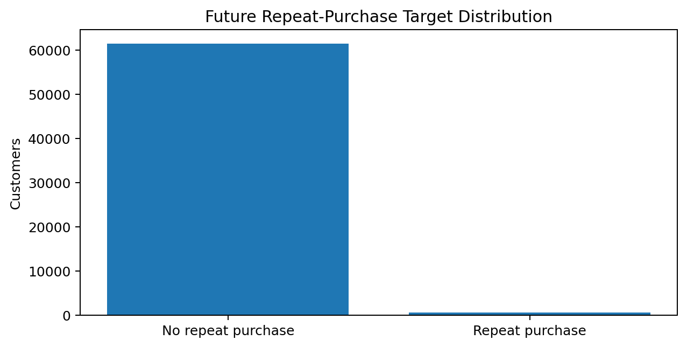
Of 62,145 historical customers, 61,544 did not make a future delivered purchase and 601 did. The positive class is only 0.97% of the population.

8. Model Development
The baseline model is Logistic Regression. It was selected because it provides an interpretable classification benchmark and probability estimates without introducing unnecessary model complexity at the first iteration.
The preprocessing and model are implemented together in a scikit-learn pipeline:
StandardScaler
↓
Logistic Regression
StandardScaler is used so that feature magnitude does not dominate the linear model. class_weight="balanced" is used because the positive class represents only 0.97% of the modeling population.
The dataset is split 80/20 using stratification and random_state=42.
Split | Customers | Repeat purchasers
Training | 49,716 | 481
Test | 12,429 | 120

Stratification is important here because a random split without it could produce an unstable representation of the already-small positive class.

9. Model Evaluation
Accuracy is not used as the primary measure because a classifier that predicts nearly everyone as non-repeat could achieve very high accuracy while failing to identify the behavior of interest.
Metric | Result
Precision | 1.36%
Recall | 56.67%
F1-score | 2.65%
Average Precision | 2.18%
ROC-AUC | 0.618

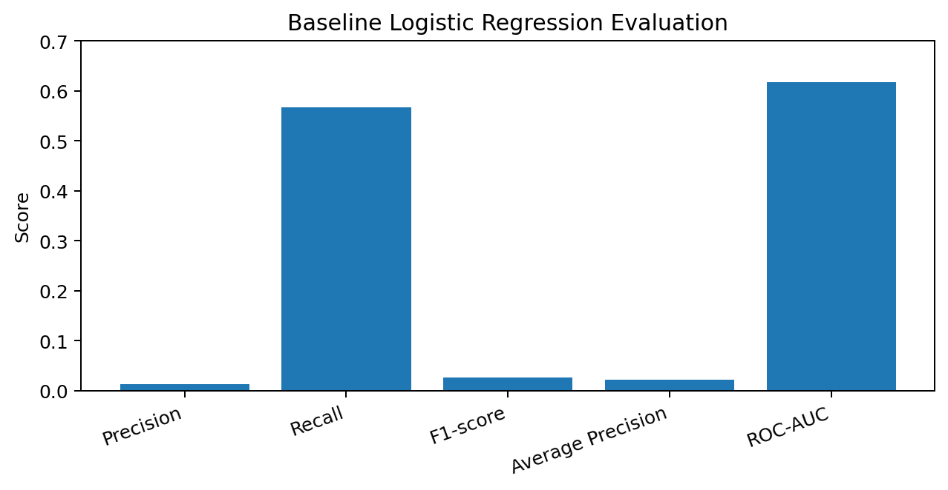
At the default 0.50 threshold, the model correctly identified 68 of the 120 repeat purchasers in the test set, while also producing 4,943 false positives.
 | Predicted 0 | Predicted 1
Actual 0 | 7,366 | 4,943
Actual 1 | 52 | 68

The combination of moderate recall and very low precision means the baseline identifies a substantial portion of repeat purchasers but casts a very wide net.

10. Threshold Analysis
The model produces probabilities that can be converted into binary decisions using different classification thresholds. Because the target is rare, threshold selection can materially change the number of customers flagged as likely repeat purchasers.
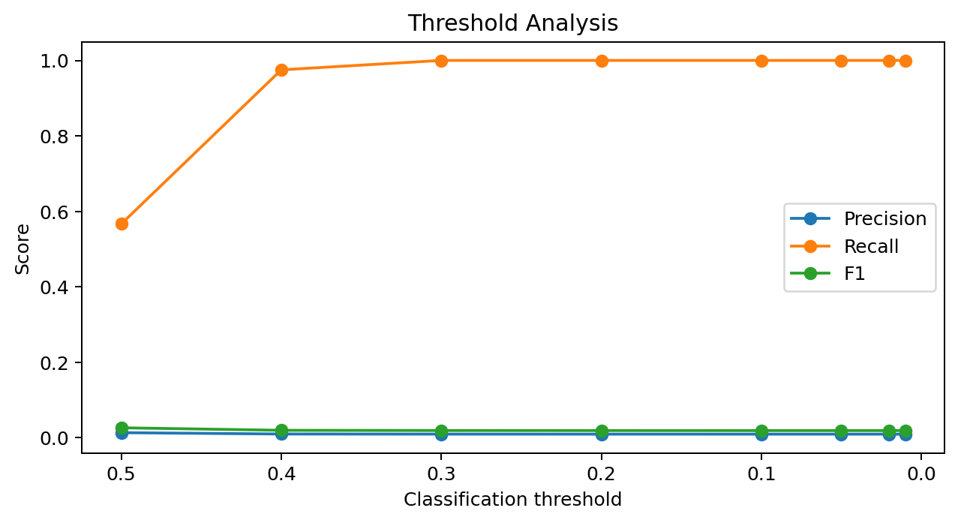
Threshold | Precision | Recall | F1
0.50 | 1.36% | 56.67% | 2.65%
0.40 | 1.00% | 97.50% | 1.99%
0.30 | 0.97% | 100.00% | 1.93%
0.20 | 0.97% | 100.00% | 1.92%
0.10 | 0.97% | 100.00% | 1.91%
0.05 | 0.97% | 100.00% | 1.91%
0.02 | 0.97% | 100.00% | 1.91%
0.01 | 0.97% | 100.00% | 1.91%

Lowering the threshold increases recall, reaching 100% at 0.30 and below, but precision remains close to the underlying positive-class rate. Threshold adjustment alone therefore does not create a useful precision-recall balance for this baseline.

11. Findings and Interpretation
Finding 1 — The analytical problem is well-defined. Transactional data was transformed into a customer-level prediction problem with a clear temporal boundary and a target based on future observed behavior.
Finding 2 — Repeat purchase is rare. Only 601 of 62,145 historical customers repeated during the future window, producing a 0.97% positive-class rate. This makes class imbalance central to the analysis.
Finding 3 — The initial behavioral features contain some signal. The Logistic Regression baseline produced ROC-AUC of 0.618 and Average Precision of 2.18%, indicating separation above an uninformative ranking while remaining weak as a practical targeting model.
Finding 4 — The baseline has a precision problem. At the default threshold, recall is 56.67% but precision is only 1.36%. Many customers flagged by the model are not observed repeat purchasers.
Finding 5 — Threshold tuning does not solve the underlying limitation. Lower thresholds increase recall substantially, but precision remains extremely low. This suggests that better features and model comparison are more important next steps than threshold tuning alone.
Finding 6 — Feature limitations are visible in the source population. Frequency is heavily concentrated at one order, while monetary value and AOV are strongly right-skewed. These characteristics constrain what a small RFM-style feature set can learn.
The correct interpretation is not that the model is production-ready. The project establishes a valid baseline, quantifies its limitations, and identifies the specific modeling weaknesses that should be addressed next.

12. Limitations
- Olist is a historical Brazilian e-commerce transaction dataset rather than a subscription business.
- Repeat purchase is an observed future behavior during a defined window, not contractual churn.
- Most historical customers have only one qualifying purchase, limiting frequency variation.
- The available dataset covers a finite historical period, and October 2018 is incomplete.
- RFM and AOV do not capture every behavioral factor that may influence future purchasing.
- The severe class imbalance makes naive accuracy misleading.
- The baseline model has very low precision, limiting its suitability for direct customer targeting.
- The model describes associations in the available data and does not establish causality.
- Predicted probabilities are estimates of observed patterns, not guarantees of future customer behavior.
These limitations are treated as part of the project findings rather than hidden from the reader.

13. Future Development
The current repository intentionally stops at an interpretable baseline. The following extensions are documented as future work rather than presented as implemented results.
Area | Potential extension | Reason
Feature engineering | Log transformations for monetary, frequency and AOV | Address strong right-skew
Behavioral features | Tenure, category diversity, average time between purchases | Capture behavior beyond RFM
Model comparison | Random Forest and XGBoost | Test nonlinear relationships
Error analysis | False-positive and false-negative investigation | Understand where the baseline fails
Decision threshold | Business-specific threshold selection | Align flags with operational cost
Customer analytics | Purchase propensity and segmentation | Broaden customer intelligence use cases

The longer-term direction is to combine repeat-purchase prediction with customer segmentation and broader purchase-propensity analysis, while preserving the same emphasis on temporal validity and explainability.

14. Reproducibility and Repository Structure
The notebooks use repository-relative paths rather than machine-specific absolute paths. The workflow is intentionally split into data preparation and model training.
01_Customer_Data_Preparation.ipynb
↓
data/processed/modeling_data.csv
↓
02_Model_Training_&_Evaluation.ipynb
The first notebook creates the final customer-level modeling dataset. The second notebook consumes that exported dataset for model training and evaluation.

Repository structure
OLIST-Customer-Purchase-Analytics/
├── data/
│ ├── cleaned/
│ ├── database/
│ └── processed/
│ └── modeling_data.csv
├── notebooks/
│ ├── 01_Customer_Data_Preparation.ipynb
│ ├── 02_Model_Training_&_Evaluation.ipynb
│ └── README.md
├── grain_level.png
├── OLIST_ER_Diagram.png
├── README.md
└── requirements.txt
Core technologies: Python, pandas, NumPy, Matplotlib, Seaborn, scikit-learn, SQLite, Jupyter Notebook, Git, and GitHub.

Reproduction steps
- Clone the repository.
- Create and activate a Python virtual environment.
- Install dependencies from requirements.txt.
- Ensure the cleaned Olist data is available under data/cleaned/.
- Run 01_Customer_Data_Preparation.ipynb.
- Run 02_Model_Training_&_Evaluation.ipynb.
The first notebook generates data/processed/modeling_data.csv, which is consumed by the modeling notebook.

15. Technical Competencies Demonstrated
Area | Demonstrated work
Data analysis | Customer-level EDA, descriptive statistics, distributions and class-balance analysis
Data engineering | Transactional-to-customer aggregation with attention to grain
SQL / database foundations | Olist relational structure and upstream SQLite ETL foundation
Python | pandas-based preparation, feature engineering and validation
Machine learning | scikit-learn Pipeline, StandardScaler and Logistic Regression
Model evaluation | Precision, recall, F1, Average Precision, ROC-AUC and confusion matrix
Imbalanced classification | Stratification, balanced class weights and threshold analysis
Analytical reasoning | Temporal split, leakage prevention and explicit limitation analysis
Documentation | Reproducible notebook workflow and structured project documentation

16. Conclusion
Olist Customer Purchase Analytics demonstrates a complete customer-level predictive analytics workflow built on a validated transactional data foundation. The project moves from data-model understanding and customer identity resolution through temporal feature engineering, exploratory analysis, model training, evaluation, and interpretation.
The most important outcome is not a claim of production-ready prediction. Instead, the project establishes a reproducible and technically defensible baseline, quantifies its limitations, and identifies specific next steps for improving customer purchase propensity analysis.
The resulting workflow provides a foundation for continued portfolio development into richer customer behavioral features, segmentation, model comparison, and customer intelligence analysis.
Project repository: https://github.com/ReinSoup/OLIST-Customer-Purchase-Analytics
Upstream project: https://github.com/ReinSoup/OLIST-Data-Quality-ETL

